**Author Agreement Statement**

We the undersigned declare that this manuscript is original, has not been published before and is not currently being considered for publication elsewhere. We confirm that the manuscript has been read and approved by all named authors and that there are no other persons who satisfied the criteria for authorship but are not listed. We further confirm that the order of authors listed in the manuscript has been approved by all of us. We understand that the Corresponding Author is the sole contact for the Editorial process. He/she is responsible for communicating with the other authors about progress, submissions of revisions and final approval of proofs Signed by all authors as follows:

Corresponding author: _____ Md Jamal Uddin_____ _______ _____15-Aug-22_____

Name Signature               Date

Authors: ____Mohammad Nayeem Hasan___ _____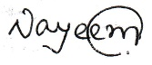_____ ______15-Aug-22______

Name Signature               Date

___ Muhammad Abdul Baker Chowdhury __ ____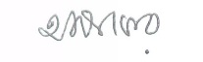___15-Aug-22_____

Name Signature               Date

____ Maya Biswas_______ ________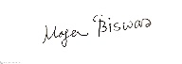_______ ______15-Aug-22____

Name Signature               Date

____ Moumita Paul _______ _________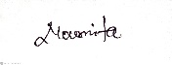______ ______15-Aug-22_____

Name Signature               Date

___ Tanvir Ahammed ___ _________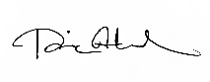______ ______15-Aug-22_____

Name Signature               Date